==============================================================================

FOLDER STRUCTURE:
ProjectFolder
│
├── Test.java
│
└── com
└── myapp
└── Employee.java
COMMAND:
package com.myapp;
public class Employee
{
public void show()
{
System.out.println("This is Employee class");
}
}

import com.myapp.Employee;
public class Test
{
public static void main(String[] args)
{
Employee e = new Employee();
e.show();
}
}

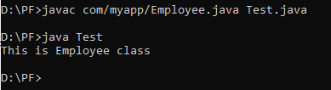
OUTPUT:

